Interim Branding Guide

2015 Q1

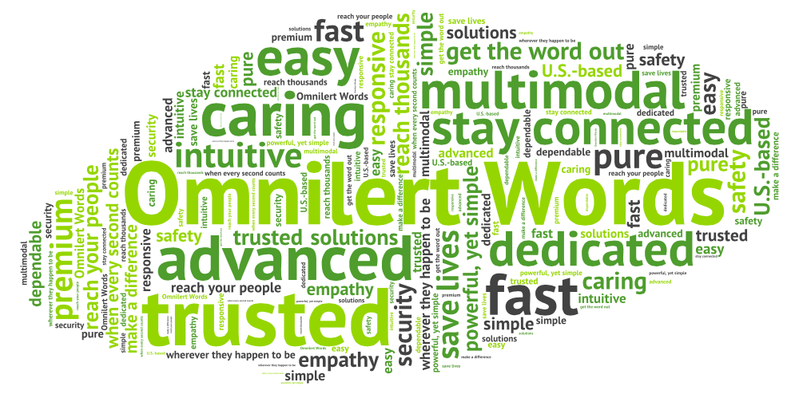

Overview
This document is designed to provide a convenient cheat sheet for marketing document production until the new Planit branding is available later in the year.

PlanIt Brand Essence
Our technology is based on hardcore science. Every little message we send, millions of them every day, has a world of complexity and incredible programming baked inside. But what drives us comes from a much different place. We were compelled to create these products out of compassion, care, and a genuine concern for bettering the world around us. This company was started by – and exists for – people trying to make a difference. People trying to solve problems. People trying to save lives. So what we are, above all, is a partner who seeks to understand our customers’ biggest needs. Ultimately it’s empathy, not technology, that fuels us to create ways for our customers to get the word out more easily.
After all, we were born out of a crisis. Our focus was clear: avert the next one. So the blood, sweat, and tears we’ve poured into our company were always because of that. It’s always been about listening, supporting, building strong ties with our customers.
In the end, this is about something very simple and pure. Connecting humans to humans, and giving them peace of mind. Quickly, clearly, intuitively. Customers depend on us to get the word out whenever and however necessary. So we’ve got your back, and we have to deliver. You’ve got our guarantee that we will.

Tagline: We make the connections that count

Core Message: The pioneer in critical communications, Omnilert connects people quickly, clearly and intuitively when the unexpected happens.

Omnilert Descriptions

50-Word Description
Omnilert’s award-winning emergency notification systems make it easy to reach your people wherever they happen to be. More than 20,000 organizations depend on Omnilert to send alerts via SMS text, email, voice messages, social media, web widgets, and an array of additional safety endpoints from one simple interface. www.omnilert.com

75-Word Description
Omnilert’s award-winning emergency notification systems make it easy to reach your people wherever they happen to be. More than 20,000 organizations depend on Omnilert to send alerts via SMS text, email, voice messages, social media, web widgets, and an array of additional safety endpoints from one simple interface. Headquartered in Leesburg, Virginia, the company sells alerting solutions under the brand names Omnilert, e2Campus, Amerilert and RainedOut. www.omnilert.com

100-Word Description
Omnilert’s award-winning emergency notification systems make it easy to reach your people wherever they happen to be. More than 20,000 companies, schools, and other organizations depend on Omnilert to send emergency alerts via SMS text, email, voice messages, social media, web widgets, and an array of additional safety endpoints from one simple interface. Visit us online to learn why leading organizations such as the U.S. Army, Verizon Wireless, Bayer, Mazda, Cal Poly, YMCA, American Red Cross, and UNICEF depend on the company’s Omnilert, e2Campus and RainedOut brands for their critical communications. www.omnilert.com

e2Campus Descriptions

50-Word Description
The award-winning e2Campus emergency notification system from Omnilert helps schools and universities reach students and faculty wherever they happen to be. From one simple interface, users can send emergency alerts via SMS text, email, voice messages, social media, web widgets, and an array of additional safety endpoints. www.e2Campus.com

75-Word Description
The award-winning e2Campus emergency notification system from Omnilert helps schools and universities reach students, faculty and staff wherever they happen to be. From one simple interface, users can quickly and easily send emergency alerts via SMS text, email, voice messages, social media, web widgets, and other safety endpoints. Learn why leading institutions such as Davidson, Carnegie Mellon, Lehigh, Cal Poly, The Baylor School, and Gilman School depend on e2Campus for their critical communications. www.e2Campus.com

100-Word Description
The award-winning e2Campus emergency notification system from Omnilert helps schools and universities reach students, faculty and staff wherever they happen to be. From one simple interface, users can quickly and easily send emergency alerts via SMS text, email, voice messages, social media, web widgets, and an array of additional safety endpoints. Visit us online to learn why leading institutions such as Davidson, Carnegie Mellon, Lehigh, Cal Poly, The Baylor School, Cathedral School for Boys and Gilman School depend on e2Campus for their critical communications. www.e2Campus.com

Standard Feature Descriptions

Native Endpoints
SMS | SMS services send concise 160 character messages directly to mobile devices. The Omnilert platform can deliver more than 80K text messages per minute to mobile carriers.
Email | More than 85% of US adults can receive electronic messages via POP, IMAP, and web mail services and 58% own smart phones with email capability. The Omnilert platform can send 50 million+ email messages per day.
SEED Email | Single Entry Email Delivery (SEED) can be used to BCC and alert to any email address. This feature can be used to conveniently send messages to local distribution lists.
Voice messages | Omnilert’s voice alerts service calls users on a landline or cell phone with a pre-recorded or text-to-speech message. The Omnilert platform can send more than 60K voice messages per minute.
Voice Cast | Voice Cast allows you to send a separate voice call to one or more numbers when issuing an alert. It provides a convenient interface for sending special purpose voice calls to distribution systems such as sirens and alarm systems, internal PA systems and centralized voicemail systems.
Desktop Alerts | Omnilert’s native desktop alerting application allows you to display alert messages directly to recipients’ laptop and desktop computer screens. Admins can choose full screen display for urgent warnings, scrolling messages for important alerts and pop-ups for simple notifications.
Web Widgets | Website widgets can be used to publish your Amerilert alerts directly to any web page. Simply paste the widget code into the HTML source of the web page and your urgent message will appear automatically whenever you issue an alert.
Facebook | Send alerts directly to your organization's Facebook page via the Omnilert Facebook app.
Twitter | Send alerts directly to your organization’s Twitter account to broadcast critical messages to your followers.
RSS | RSS feeds allow your stakeholders to get critical communication updates from you delivered directly to desktop or web RSS reader along with updates from their favorite news and blog sites. The Omnilert platform publishes your customizable feeds and offers copy-and-paste code for creating clickable buttons for the most common RSS compatible portals including My Yahoo, My AOL, and Windows Live. We serve about one billion RSS feeds per year.
TTY | The Omnilert TTY service provides an option for delivering calls formatted for broadcast to teletypewriter systems for the hearing impaired.

Omnilert Features
Scenario Manager | Scenario Manager makes it easy to thoroughly plan and quickly implement complex, multi-stage responses to emergency situations. You can set up a scenario response with multiple unique actions such as initiating an outbound conference call, sending different messages to different groups with different endpoints, or even requesting status or feedback. In a crisis situation, the entire set of actions can be initiated with one click from the admin screen or remotely with the Scenario Launcher iPhone or Android app.
Instant teleconferencing | uConference leverages your existing bridge call service to link your decision team for real-time collaboration. It automatically calls designated employees and allows them to immediately join the conference simply by pressing a button on their phone.
SMS Inbox | SMS Inbox organizes incoming responses to critical alerts so administrators can quickly view and respond to inbound text or email message replies and gain better situational awareness during a crisis.
uTip Inbound tips via email, SMS and Web | uTip makes it easy for your community to report possible security and safety issues. Receive tips via identified or anonymous text messages, emails or web forms.
Inbound Hotline | Much like an answering machine or voice mail system, the Hotline service plays your critical message whenever someone calls in to your dedicated hotline number. It can handle hundreds of simultaneous calls, thus preventing your internal phone systems from getting jammed in an emergency.

Administration Options
Public groups | Public groups allow users to subscribe/unsubscribe themselves during registration and through your web portal. Use public groups for optional content streams, such as organization-specific  alerts, informational alerts, or non-critical messaging.
Private groups | Private groups are administrator-controlled delivery groups. Users are not permitted to self-subscribe to private groups. Use Private groups for internal, private communications between groups such as first responders, high level staff, or law enforcement officials.
Mobile opt-in |  | Mobile Opt-in allows your users to subscribe simply by texting your short code (a short format phone number for SMS messages) and then confirming their subscription by replying with “Yes” when prompted.
Expiration dates | When a user creates a new account, an expiration date (opt-out date) can be automatically assigned or updated later. Users with expired accounts no longer receive alerts or show as active users in the system.
Message templates | Use message templates to save time in an emergency. Compose and save messages for common types of alers. When you’re ready to send, the system will pre-fill the approved message text which you can quickly customize for the immediate situation.
SmartCode | SmartCode makes integrating Omnilert forms and content into your existing websites quick and easy. Simply cut and paste the custom JavaScript snippets wherever you want a login, sign up form or other element. Customize them to match your existing sites with easy CSS styling.
Bulk Upload | Use the bulk upload utility to do mass uploads, additions, updates and deletions of user information to efficiently keep your subscriber lists up to date.
FTP upload
Advanced Technology Support
API access | Integrate your Omnilert and e2Campus implementation with your existing directly via Omnilert's built-in application programming interface.
Shibboleth (Single Sign On) | Omnilert, a member of the InCommon Federation, supports the open source Shibboleth (Single Sign On) authentication protocol. You must be a member of InCommon to implement this feature.
LDAP
CAP | The Common Alerting Protocol (CAP) is OASIS.org’s open standard format for exchanging emergency alerts and public warnings. The Omnilert platform is fully compliant allowing users to produce CAP feeds and push CAP messages to a designated URL.
SNPP gateway | Is this supposed to be SMTP?
Export | Easily export your user and admin information to CSV (Comma Separated Value) format text files which can be opened in Excel or other spreadsheet apps.
Unparalleled Customer Service
Customer support 24/7/365 | Omnilert offers the industry’s highest quality customer support. Each customer has a dedicated account manager and 24/7 access to a US-based support team in addition to a comprehensive online help system.
Ultra-reliable Platform | The Omnilert platform features advanced geographic and system-level failover and full redundancy to ensure 99.999% uptime. This keeps our systems available regardless of technical issues, weather conditions or regional disruptions.

Omnilert Logos and Fonts
Omnilert logos in various formats are located in Dropbox:
Dropbox/Omnilert Docs/Sales and Marketing/Graphics/Logos

The logo font is Harabara.

Omnilert Website Fonts

Proxima Nova - Headlines
Myriad Pro - content

Omnilert Colors

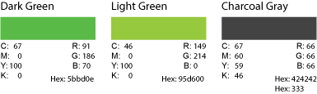

Omnilert Words

Omnilert Words
trusted
powerful, yet simple
caring
responsive
multimodal
advanced
premium
dedicated
solve problems
save lives
when every second counts
fast
easy
get the word out
U.S.-based
reach your people
intuitive
reach thousands
stay connected
make a difference
safety
security
simple and pure
depend on us
empathy
solutions
wherever they happen to be

